

Leah Mancuso Harrington - March 2013

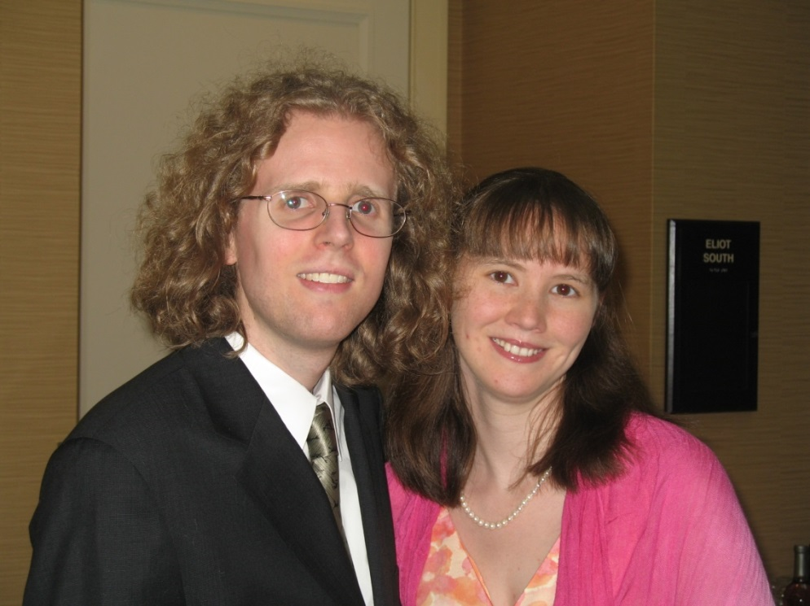

Matthew Sterling Harrington, son of Gregory Harrington, with his wife,

Branwen I. Hardebeck-Durso Harrington – 3 July 2010